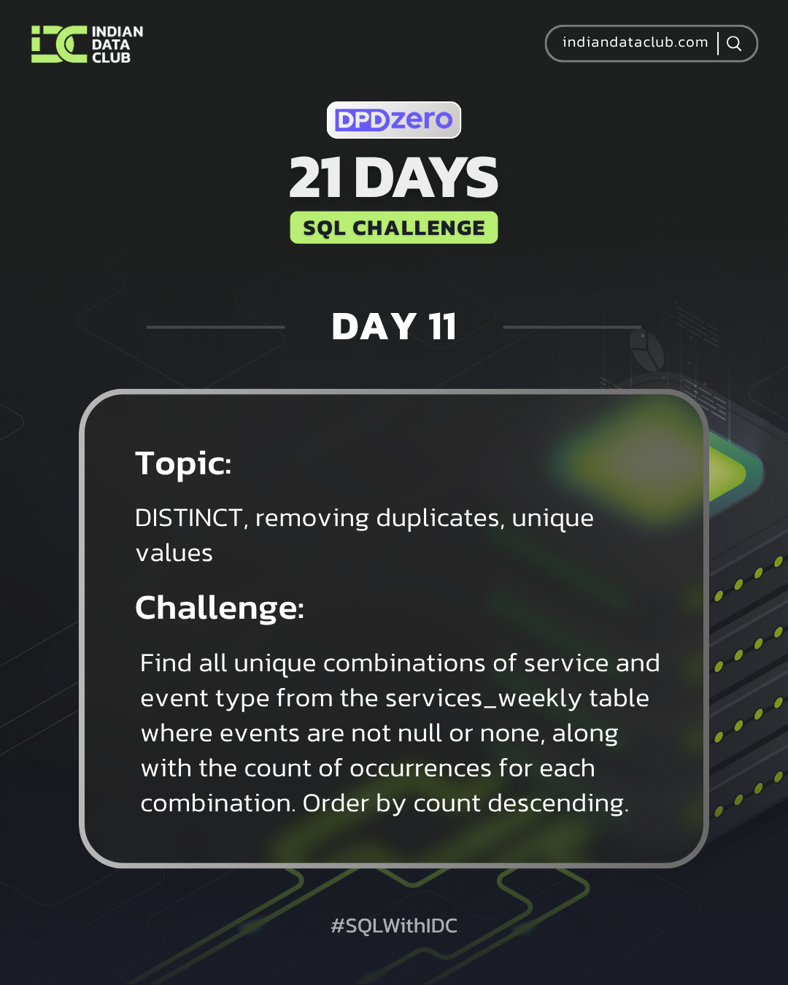Day-11 SQL Challenge
Day-11 Challenge:
Find all unique combinations of service and event type from the services_weekly table where events are not null or none, along with the count of occurrences for each combination. Order by count descending.
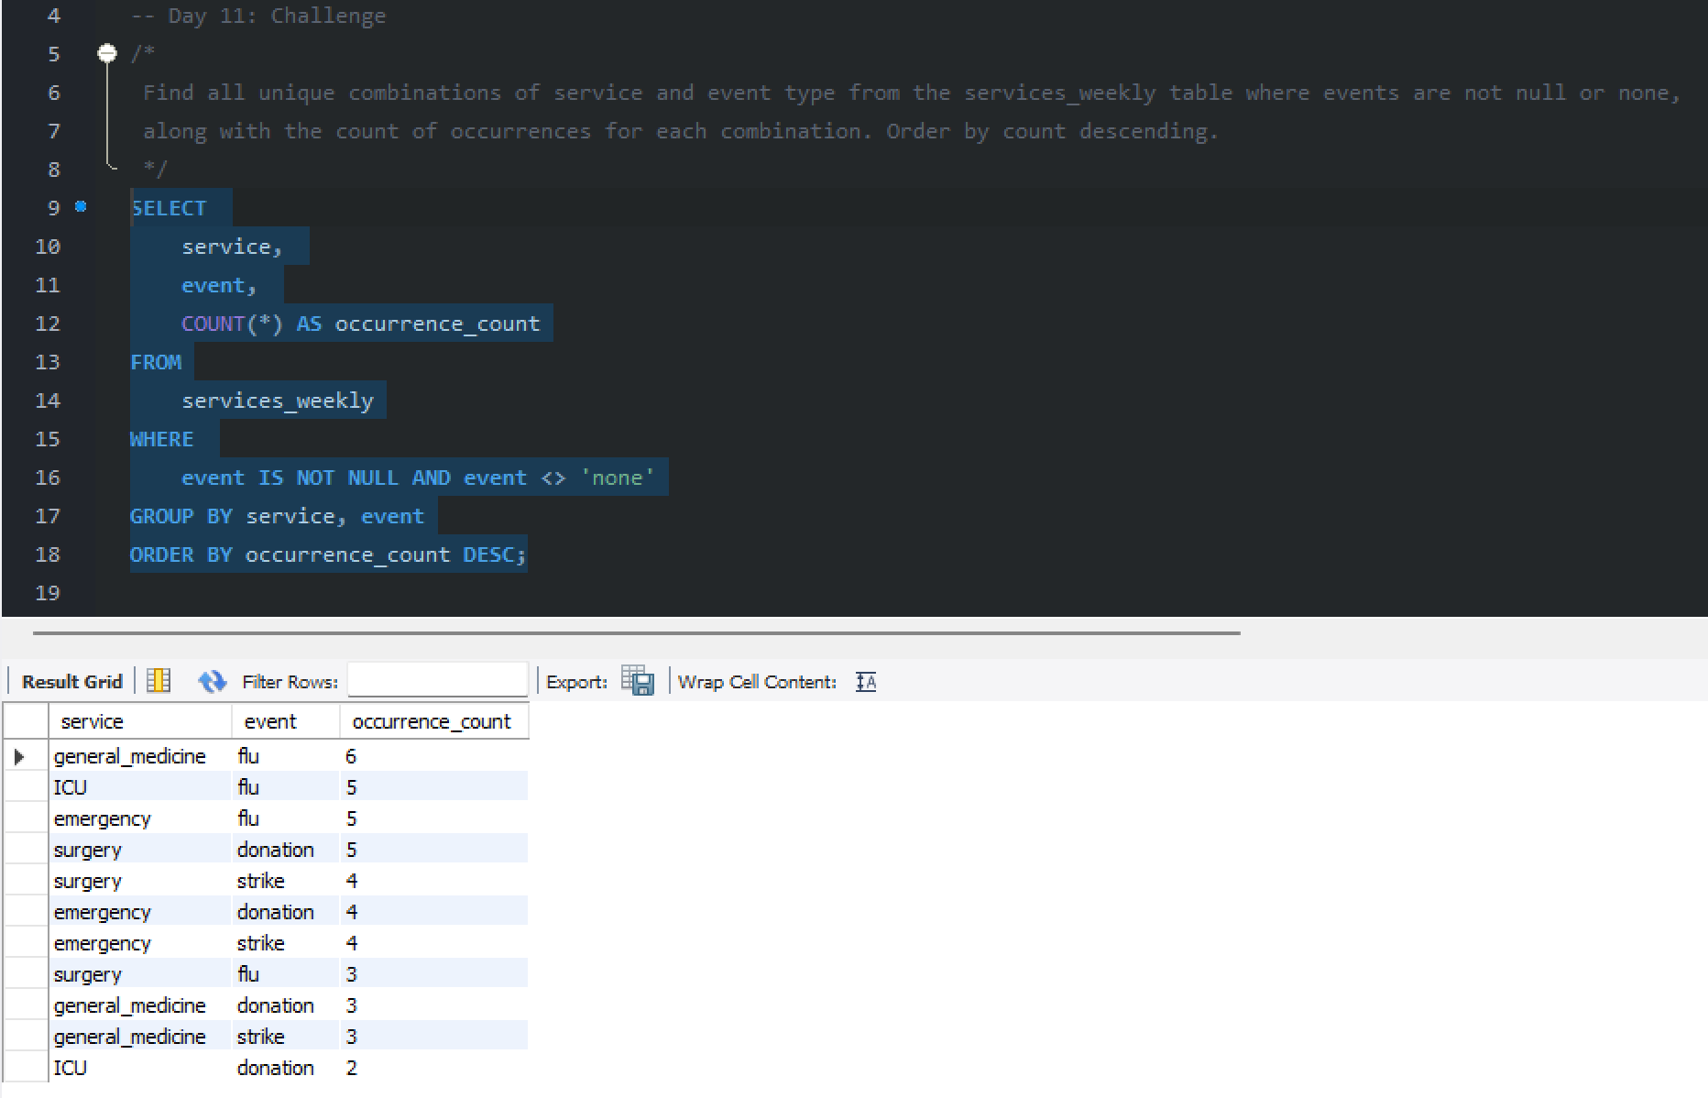

Practice Questions:
1. List all unique services in the patients table.
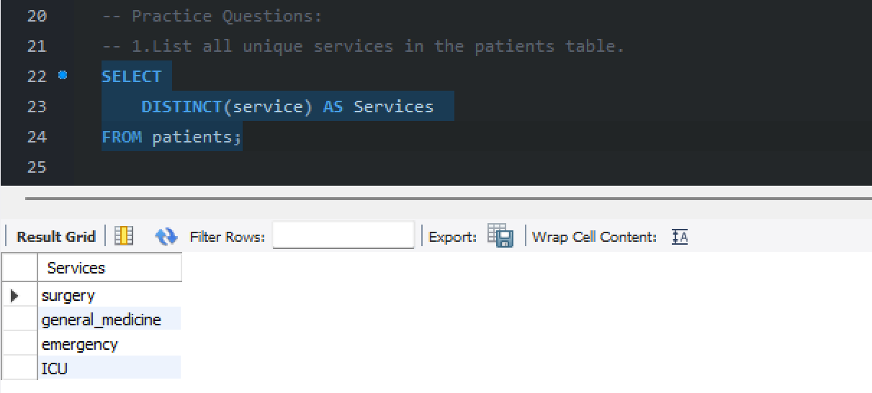
2. Find all unique staff roles in the hospital.
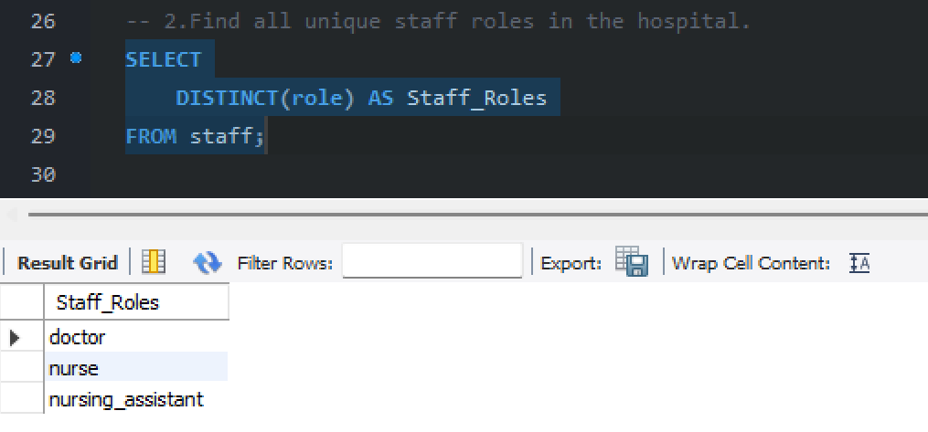

3. Get distinct months from the services_weekly table.
